- . To Create Process Escape Sequences, Handle Escaped Spaces, Escape Special Symbols, Preserve Characters, Validate Parser Output, Test Complex Inputs.

Aim : To create and test process escape sequences in Ubuntu, handle escaped spaces, escape special symbols, preserve characters, validate parser output, and test complex inputs.

Program :
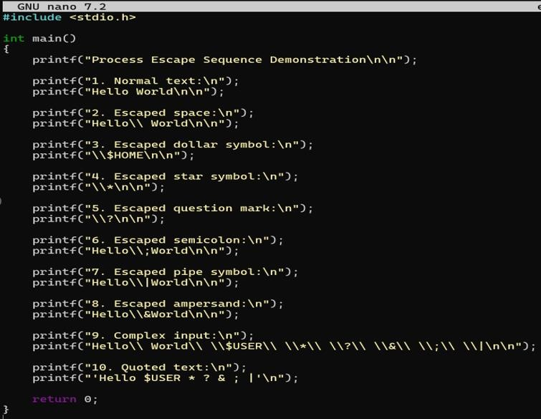

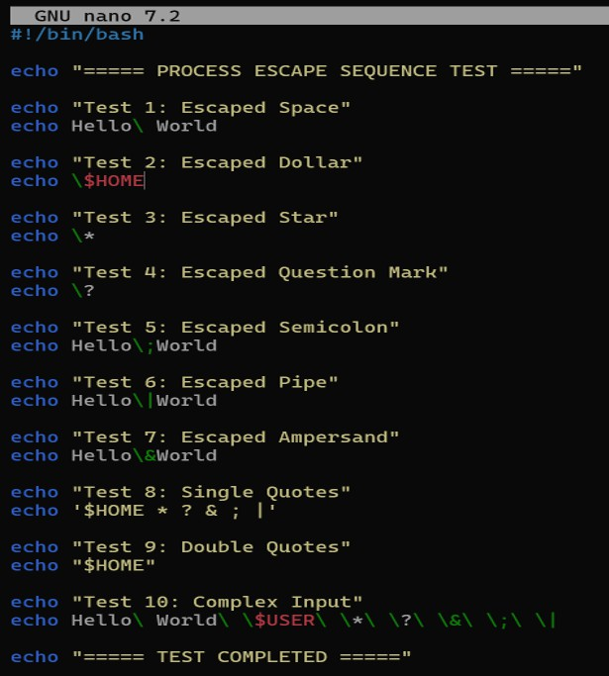

Output :
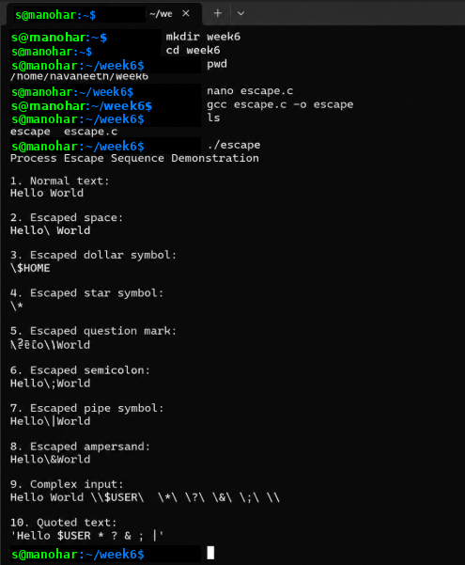

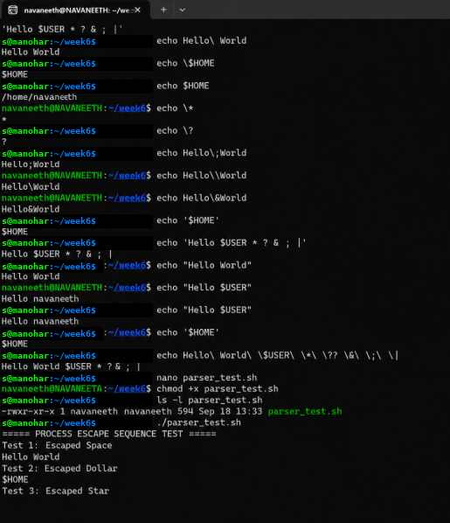

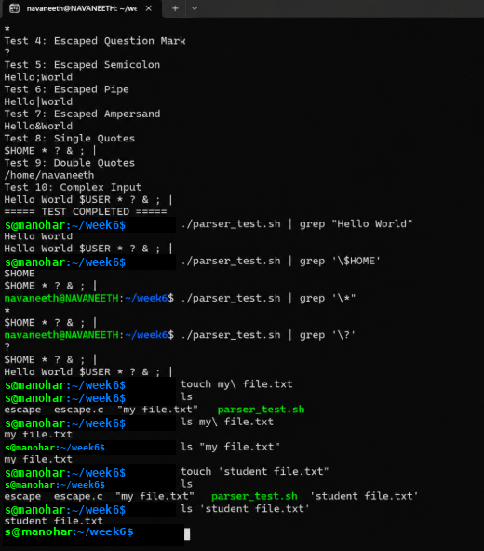

- . To Create Child Processes, Execute Programs, Handle Execution Errors, Pass Arguments, Manage Parent Process, Test Command Launching.

Aim : To create a child process using fork(), execute another program using exec(), handle execution errors, pass arguments to the executed program, manage the parent process, and test command launching in Ubuntu.

Program :
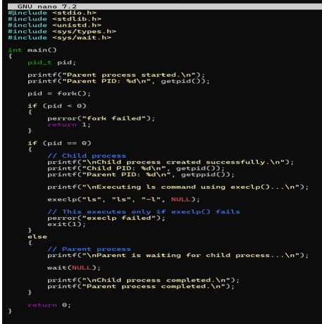

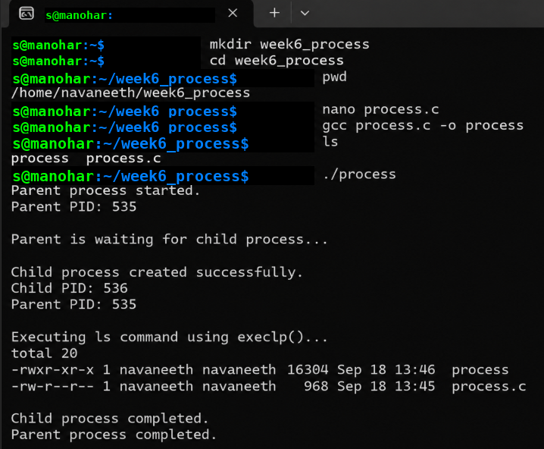Output :

